Get ready for Arbutus Analyzer 8 Virtual Training
Arbutus Analytics Virtual Instructor-led Training (vILT) offers all the benefits of in-person training without the travel. There is two-way audio and visual between the instructor and the participants, there are group discussions and individual exercises.
Follow these guidelines to configure your learning environment to make the most of the training:
- Select a quiet location with minimal distractions. Please be considerate of everyone attending the training session.
- Have the right equipment: fast, reliable WIFI; audio headset; webcam; a minimum of two screens.
- Prepare to be in the virtual classroom during the designated virtual class hours.
- Bring your questions: Your instructor knows the tool; you know what’s needed in your role -- Your questions allow the instructor to provide guided knowledge you can immediately apply to improve your on-the-job performance.

We provide:
Meeting platform: GoToTraining will send an email one week, one day and one hour prior to the start of training. Each of these emails will contain your personal link to join the training sessions.
Training Manual: We’ll provide the training manual electronically as a PDF document.
Training data files: We provide a link to download the training data files.

You provide (required):
Computer/laptop with Analyzer 8 installed and activated. Please advise your instructor immediately if you do not have an Analyzer license and we’ll provide a temporary license for you to use during the training. Important: There were a number of enhancements added in Analyzer Version 8. We strongly advise you to wait to attend training if you do not have Analyzer Version 8 installed.
Two screens: You need one screen for Analyzer and one screen for viewing the instructor’s computer in the virtual classroom.
Printed copy of the Training Manual: Print the manual we send you ahead of time in case you want to make notes.
Audio headset: You need to be hands-free. You can use an audio headset and computer audio or dial in on your phone. Either way, you’ll need hands-free. Test your audio set up and headset prior to your virtual class.
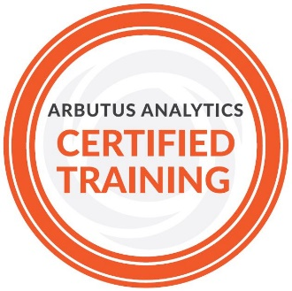
Webcam: You must be visible in the virtual classroom in order to qualify for NASBA-approved CPE credits for this training. Please ensure your webcam is ready and on.
We look forward to seeing you in the virtual classroom!

